Terms of Reference
Project Coordinator to support the implementation of the eCase Management System for anti-corruption institutions of Ukraine

EU Anti-Corruption Initiative in Ukraine
August 2019
Background
The current criminal pre-trial investigation and prosecution system in Ukraine requires big volume of paperwork, which slows down significantly information sharing between the institutions involved in the proceedings as well as third parties. Many European countries have already shifted from paper files to having a comprehensive eCase Management System.
The implementation of an integrated eCase Management system in Ukraine for the National Anti-corruption Bureau of Ukraine (NABU), Specialised Anti-Corruption Prosecutor’s Office (SAPO) and investigative judges in the High Anti-Corruption Court (HACC) will contribute significantly to enhancing pre-trial investigation performance and will increase the efficiency of anti-corruption cases under investigation.

The integrated system will enable efficient electronic interaction of detectives, prosecutors, and judges in pre-trial investigation, speed up decision-making, decrease routine travel time, save costs and increase time to be devoted to investigations rather than routine administration.
The eCase management system will be designed and developed to supply with techniques to register and track all case events, enhance record-keeping, reduce delays and case backlogs and provide information to support strategic allocation of time and resources. The eCase MS may also improve the predictability of events, which can ensure accountability, increase public trust, reduce opportunities for corruption and enhance transparency of the Beneficiaries’ administration.
The eCase Management system is supposed to provide extensive functionality for automation of the pre-trial investigation workflow, for instance:
- Make communications between the detectives, prosecutors and the court in an electronic form;
- Create / register new or merge existing criminal cases;
- Assign detectives and prosecutors to criminal cases, set up investigation and prosecution groups;
- Document procedural actions, as well as create, review and approve respective procedural documents (protocols, complains etc.);
- Upload, download and view all the annexes to the procedural documents including scan-copies, photos, audio- and video-records;
- Enter and modify / update information on the participants of the criminal cases;
- Plan execution of procedural actions and track status of their delivery, assign and track deadlines to the actions;
- Perform automated data exchange with external state registers and databases;
- Segregate and control user access to the system to ensure proper information security in terms of pre-trial investigations.

The goal of the project is to deliver a centralised eCase Management System for the following beneficiaries: the NABU, Specialised Anti-Corruption Prosecutor’s Office (SAPO) and High Anti-Corruption Court (HACC). The scope of the system covers the necessary software, both standard and customised, infrastructure devices, system hardware, ancillary services, training, warranty, maintenance and support. The eCase MS is therefore a complex system, far beyond the boundaries of just a custom application software.

The tender for the eCase implementation was launched on 29 March 2019:
https://ted.europa.eu/TED/notice/udl?uri=TED:NOTICE:146918-2019:TEXT:EN:HTML
According to the projected timeline, the project of developing and piloting eCase Management system should start in August 2019 and to be completed by April 2020. Taking into consideration the huge volume of the planned activities, their complexity, as well as multiple involved stakeholders, the EUACI developed a governance model and set up respective bodies to run and support the eCase implementation. The governance organization will include the Steering Committee, Quality Assurance team, working groups and Project Management Office (PMO). The overall governance model for the project is depicted in the diagram below.
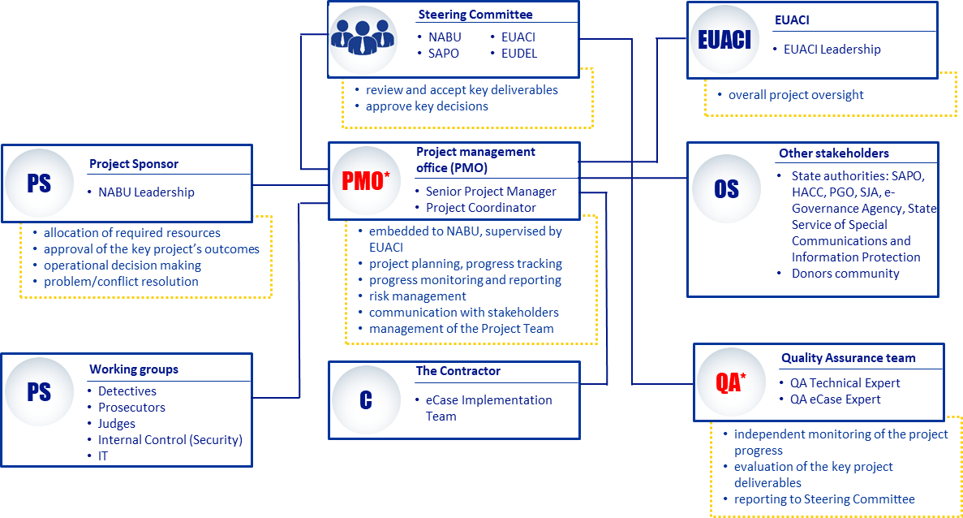
The PMO will be embedded in NABU and will report to the EUACI.
The PMO team is expected to comprise the following profiles:
- Senior Project Manager;
- Project Coordinator.

Objectives
The EUACI is looking for an experienced, responsible Project Coordinator to support the implementation of the eCase Management System for anti-corruption institutions of Ukraine.

The Project Coordinator will be in charge of assisting the Senior Project Manager in organizing the implementation of the eCase. This task involves planning meetings and project activities, monitoring project plan, organizing and participating in working groups and Steering Committee meetings, and ensuring that the project deadlines are met in timely manner.

The aim of the PMO is to ensure effective governance of the eCase implementation project for its successful implementation.
The main objectives for the PMO deployment are:
- Smooth coordination between all involved beneficiaries, stakeholders and the Contractor throughout the duration of implementation of the project.
- Provision of specialised advice on the ways to enhance the efficiency of interaction between the involved parties and support the developing and tracking of operational plans and reports.
- Recognition and measurement of the main risks, which may directly impact the likelihood of success of the project and that this risk must be both formally and informally measured throughout the lifetime of a project.
- Provision of advice and support in enhancing awareness within the NABU, the SAPO and the HACC.

Output
Outputs associated with the assignment will include:
- Coordination activities to support Project Manager.
- Assessment of administrative and operational requirements of the project during its implementation.
- Assessment of the projected schedules and deadlines, which are Proposed by the Contract and approved by the EUACI and Beneficiaries.
- Organization of the cooperation activities among the stakeholders.
Scope of work
The tasks associated with the assignment will be to:
- coordinate among the experts and working groups nominated by the beneficiaries and the Contractor’s team to make sure that all mentioned parties are on track with the project requirements, deadlines, and schedules;
- organize, participate in working groups and Steering Committee meetings, document and follow up on important actions and decisions from meetings;
- make minutes of the meetings and distribute them to all project team members;
- prepare necessary presentation materials for meetings;
- provide administrative support as needed;
- ensure all the project documentation is maintained appropriately;
- advice the beneficiaries about the involvement of resources required for the project implementation and monitor timely decision making;
- ensure that all project activities are delivered on-time, within scope and within budget;
- manage changes to the project scope and project schedule;
- report to the EUACI in coordination with the Senior Project Manager at least on a weekly basis on a status quo of the project.

Timeframe
Only those applicants that are shortlisted for interviews will be contacted.
The duration of this assignment is estimated to be 8 calendar months to commence on September 2019 and up to April 2020.
The project activities are expected to take place in Kyiv. The assignment will start following a notification issued by the EUACI, but not earlier than the date of signing the Contract between the EUACI and the Contractor on eCase implementation.

Requirements
Key qualifications of the Project Coordinator include:
General qualifications:
- University degree relevant to the assignment.
- Relevant education at least up to Masters’ Degree / Academic level or equivalent that demonstrates the ability to perform the duties and responsibilities as described;
- Minimum 3 years of professional experience managing/assessing/reforming ICT solutions as Project Coordinator/Project Manager;
- Strong managerial and coordination skills;
- Excellent communication skills.
- High levels of resilience and integrity.
Adequacy for the assignment
- Project management and planning skills;
- Strong understanding of formal project management methodologies and its practical application;
- Experience in coordinating/managing at least one complex large-scale system development/implementation/customization projects of similar nature;
- Project management experience in a donor-funded project related to management of case management systems or other ICT solutions in the justice and home affairs sector would be an asset;
- Experience in facilitating meetings and documenting results;
- Experience in leading a cross-agency project team of various sizes;

Experience with the region and languages
- Fluency in English;
- Fluency in Ukrainian / Russian.

Monitoring and evaluation
Definition of indicators
The performance of the Contractor will be judged upon reaching the purpose of this contract as well as obtaining its results, as indicated in Section ”Output” herein respectively. Moreover, the performance of the Contractor will be judged upon successful implementation of all the specific activities indicated in Section ”Scope of work” of the present document.
Special requirements
By signing the contract, the Contractor agrees to hold in trust and confidence any information or documents ("confidential information"), disclosed to the Contractor or discovered by the Contractor or prepared by the Contractor in the course of or as a result of the implementation of the contract, and agrees that it shall be used only for the purposes of the contract implementation and shall not be disclosed to any third party. The Contractor also agrees not to retain copies of any written information or prototypes in its own archive and for its own use.
Cross-cutting issues (integration of the youth, equal opportunities)
The assignment will be implemented ensuring equal opportunities for men and women and integration of the youth.
Selection
The following documents should be submitted to Mr. Torben Ulsted, tulsted@ukraine-aci.com with the subject “Project Coordinator for eCase”:
• CV of the expert;
• Motivation letter;
• Financial proposal;

Deadline for proposals submission is 14 August 2019, 17:00 Kyiv time.
Clarification questions
Questions for the Request for Bid should be addressed to Mr. Vitaliy Veselskyi, vitves@ukraine-aci.com, with a copy to Ms. Elena Konceviciute, elekon@ukraine-aci.com , not later than 12 August 2019, 17:00 Kyiv time.

